MCT EVENING CONFERENCE WEDNESDAY 23RD NOVEMBER 2022 TRAVEL GUIDE.
VENUE – RADISSON BLU HOTEL, FRANKLAND LN, DURHAM DH1 5TA.
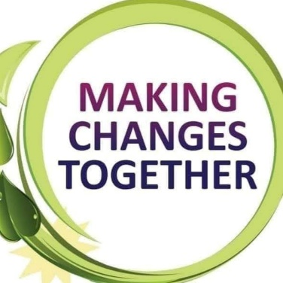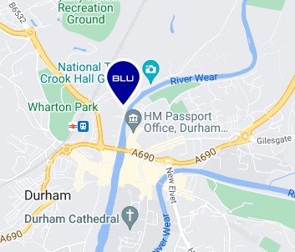
The hotel is in central Durham on the river opposite the new passport office.

BY CAR
Any central Durham car park serves the hotel.
- Park and ride closes at 7pm so not suitable for our evening conference.
CENTRAL CAR PARKS
- Hotel parking LIMITED SPACE. If using hotel car park, you will need to sign in. Please ask an MCT member on arrival.
- Riverwalk , DH1 4SL. Must use CAR PARK 2 . COST £1.50 after 5pm. 4 minute walk.
- Prince Bishops, DH1 3UJ - 0-2 HRS £2.10 , 2-4 HRS £3.30 , 4-6 HRS £6.20, 6 + HRS £11.50.
7 minutes walk.
- The Sands , DH1 1SL. Council ran so free after 2pm 4 minute walk.
- Walkergate , DH1 1SQ. COST - 0-2 HRS £2.00 , 2-4 HRS £3.10 , 4-6 HRS £5.20, 6 + HRS £9.50.
3 minute walk.
- Side Gate carpark , DH1 5SY. Council ran so free after 2pm. 2 minute walk.
- Side Gate Road parking, DH1 5SZ . Council ran so free after 2pm 2 minute walk.
- Frankland Lane, DH1 5SZ. Council ran so free after 2pm. . 3 minute walk.
- Providence Row, DH1 1LH ( only 19 spaces) Council ran so free after 2pm. 6 minute walk.
- Lovegreen , DH1 5SY ( only 20 spaces) 3 minute walk COST - 0-2 HRS £2.00 , 2-6 HRS £4.00 , 6 + HRS £5
- Framwelgate Waterside, DH1 5TA – (4 Blue Badge parking bays and 8 normal bays) Council ran so free after 2pm. 1 minute walk

All Durham County Council owned on street and off-street town centre parking is free after 2pm.

Evening - Page 1
BY BUS
Any bus to central Durham. Please search google map planner for more details on times especially for after 8pm when we finish. See a quick guide below
Buses from select towns
- STANLEY – 16 OR 16a
- CONSETT – X5 OR X15
- CHESTER-LE-STREET – 50, X21 OR ANGEL 21
- SEAHAM – 65
- PETERLEE- X62
- BARNARD CASTLE – 6
- SPENNYMOOR – X21 OR 6
- BISHOP AUCKLAND – X21 OR 6
- NEWTON AYCLIFFE – 7 sapphire
- SEDGEFIELD- X12 MAX
- CROOK – X46
- FERRYHILL - 7 sapphire OR 56

From bus stops – Go south and through Riverwalk car park, go all the way to bottom towards the river, turn left and follow river path. Hotel is on left.

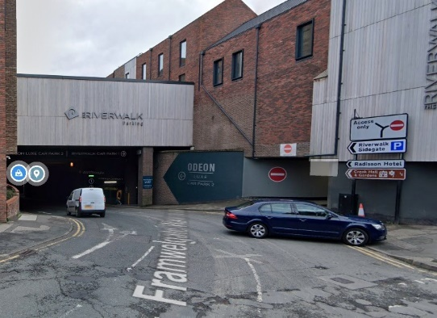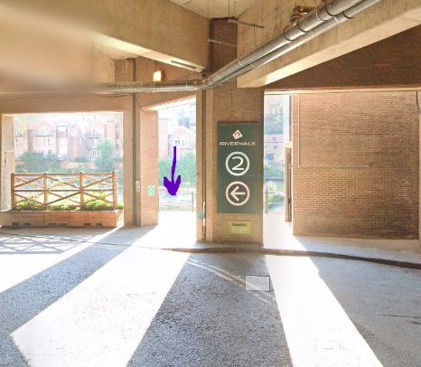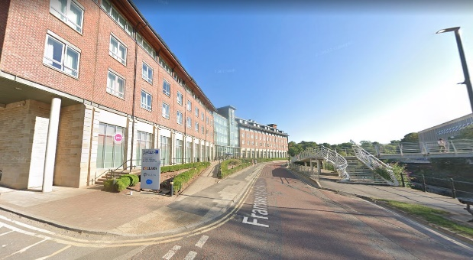
BY TRAIN

Any train to Durham will mean a 900-meter walk to the hotel. 10 minute walk

Search TRAINLINE online for routes and times. 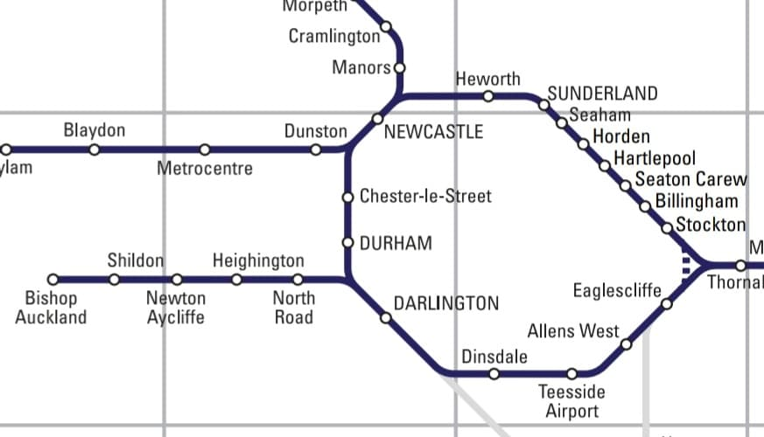

IF YOU REQUIRE ANY MORE HELP, PLEASE EMAIL INFO@MCTDURHAM.CO.UK

Evening - Page 2

