MCT DAYTIME CONFERENCE THURSDAY 24TH NOVEMBER 2022 TRAVEL GUIDE.
VENUE – RADISSON BLU HOTEL, FRANKLAND LN, DURHAM DH1 5TA.
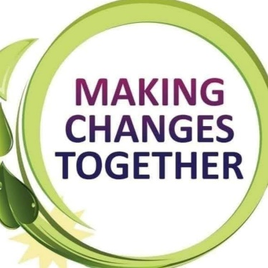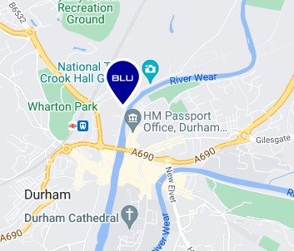
The hotel is in central Durham on the river opposite the new passport office.

BY CAR
Park and Ride
£2 per person or free after 9.30am for bus pass holder ( 50p before 9.30am)
- Belmont, DH1 1SR - on the A690, approximately 300 metres east of Junction 62 of the A1. The bus leaves park & ride at 00, 15, 30 and 45 minutes past the hour.
- Howlands Farm, DH1 3DE - less than one mile after joining A177 at the A167 / A177 roundabout. The bus leaves the park & ride at 7, 22, 37 and 52 minutes past the hour
- Sniperley, DH1 5AA - approximately 400 metres north of the A167/A691 junction. The bus leaves at 10, 25, 40 and 55 minutes past the hour.
CENTRAL CAR PARKS
- Hotel parking LIMITED SPACE. If using hotel car park, you will need to sign in. Please ask an MCT member on arrival.
- Riverwalk , DH1 4SL. Car park 1 or 2 open. COST - 0-2 HRS £1.80 , 2-4 HRS £3.00 , 4-5 HRS £4.50, 5-6 HRS £5.50, 6 + HRS £10.00. 4 minute walk
- Prince Bishops, DH1 3UJ - COST 0-2 HRS £2.10 , 2-4 HRS £3.30 , 4-6 HRS £6.20, 6 + HRS £11.50
7 minutes walk.
- The Sands , DH1 1SL. COST - 0-2 hours: £1.60 & 80p per hour thereafter. Council ran so free after 2pm. 4 minute walk
- Walkergate , DH1 1SQ. COST - 0-2 HRS £2.00 , 2-4 HRS £3.10 , 4-6 HRS £5.20, 6 + HRS £9.50.
3 minute walk
- Side Gate, DH1 5SY. COST 0-2 hours: £1.60 & 80p per hour thereafter. Council ran so free after 2pm. 2 minute walk.

Daytime - Page 1
BY BUS
Any bus to central Durham. Please search google map planner for more details on times but see a quick guide below.
Buses from select towns
- STANLEY – 16 OR 16a
- CONSETT – X5 OR X15
- CHESTER-LE-STREET – 50, X21 OR ANGEL 21
- SEAHAM – 65
- PETERLEE- X62
- BARNARD CASTLE – 6
- SPENNYMOOR – X21 OR 6
- BISHOP AUCKLAND – X21 OR 6
- NEWTON AYCLIFFE – 7 sapphire
- SEDGEFIELD- X12 MAX
- CROOK – X46
- FERRYHILL - 7 sapphire OR 56

From bus stops – Go south and through Riverwalk car park, go all the way to bottom towards the river, turn left and follow river path. Hotel is on left.
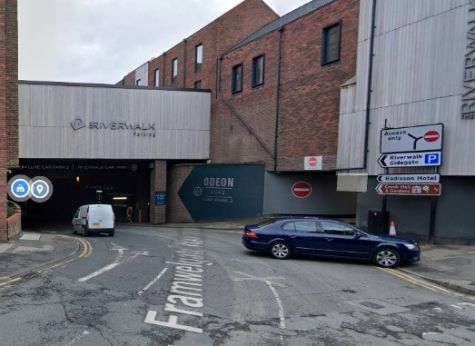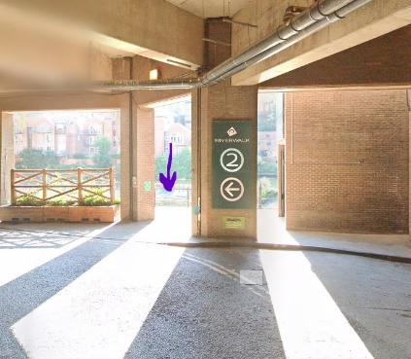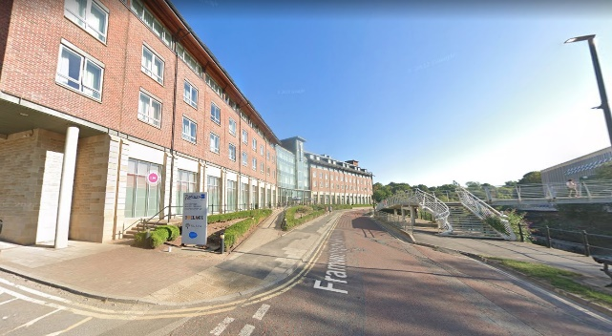

BY TRAIN

Any train to Durham will mean a 900-meter walk to the hotel.
Search TRAINLINE online for routes and times. 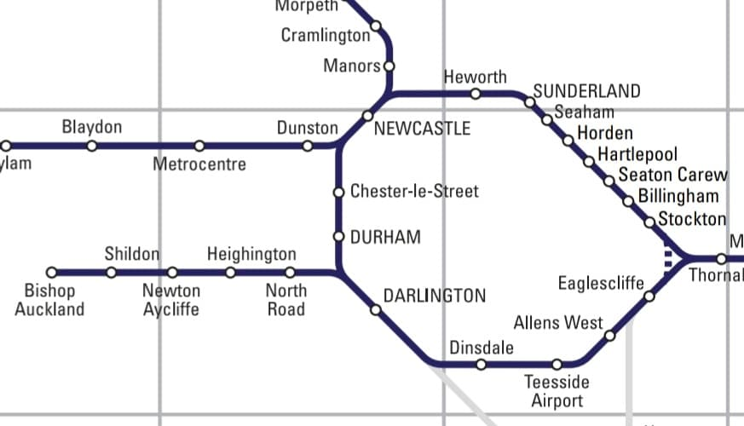

IF YOU REQUIRE ANY MORE HELP, PLEASE EMAIL INFO@MCTDURHAM.CO.UK

Daytime - Page 2

