MCT Durham PCF Conference report.

Making Changes Together Conference XXIX

Monday 12th June &
Tuesday 13th June 2023
At Ramside Hall Hotel, Durham.

MCT DURHAM CIO – Registered charity number 1202217.
www.mctdurham.co.uk
Contents Page
Welcome and introductions …………………………………… 3
Paul Shadforth ………………………………………….……………. 4
Team Training………………………………………….………………. 11
Have your say! …………………..………..…………………………… 17
DSCO – Judith Bowman…………………………………………… 18
Building a needs-led system for families with
neurodivergent children and young people…………………. 21
Needs Led Neurodevelopmental pathway ………… 24
SENDEIC – Short breaks……………………………………… 31
SENDIASS ………………………………………………………………. 37
eXtreme Group ………………………………………………………… 44
Sensory Worx …………………………………………………………. 48
PCP - Learning disability & autism project ………… 52
Raffle and Close ……………………………………………………… 60
Day conference evaluations …………………………………… 60
Evening conference evaluations ……………………………. 64

This report is distributed to many parent/carers and professionals who were unable to attend the conferences, alongside those delegates who did attend. It therefore contains all of the presentations made at both events.
All slides are also available to download via the “conference” tab of the MCT website – https://www.mctdurham.co.uk/conference-info/

Welcome by Marsha Dolan – Ellis. (MCT)

Marsha was the spokesperson for both evening and daytime events. Marsha welcomed everyone to the conference and highlighted the usual housekeeping information.
Marsha informed delegates that after 12+ years of being part of MCT this was her last conference due to moving house.
At the day conference on 13th June Marsha explained her journey and how MCT started. She also explained she still hears people say, “Nothing has changed over the years”. Marsha listed examples of changes that have occurred since she has been part of the Parent carer forum e.g. To get short breaks you previously needed a social worker whereas now you don’t.
Marsha put on a t-shirt which sums up her journey. Photo below…
Marsha’s t shirt.

Speaker - Paul Shadforth Strategic manager for SEND & inclusion.
Unfortunately due to having to attend a DVB (Delivering Better Value) in SEND (Special Educational needs and Disabilities) - conference in Leeds; Paul was unable to attend in person, so sent a video instead.

Link to video here - Paul Video . Link will work until 1/6/2024.
( https://1drv.ms/p/s!ArxABTsGy3FNkzBR-tZDl9dxHolw?e=CVb2Ib )
Pauls slides below -
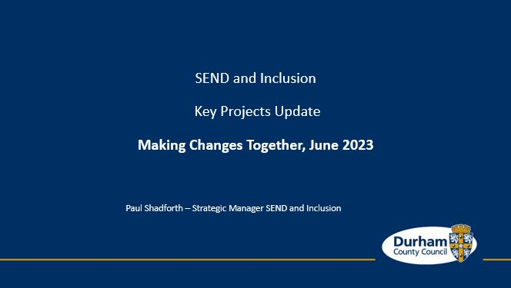
“I want to thank MCT for helping to facilitate me joining by a recorded presentation. Apologies for not being able to attend. The MCT conference is a key part of my working year. It is a great disappointment to me, to not be with you in person. I always see the conference as an opportunity to meet up with families and the professionals who support them and to learn from your experiences of living and growing up in Co Durham and exploring the opportunities to make it better for you and for others”.
“I am currently in Leeds with the DfE working on the DBV programme. It provides me an opportunity to bring some new resources into Co Durham to help us to further support our communities. It is the only reason that Amy would let me not attend in person, I hope you understand also. More on DBV later”
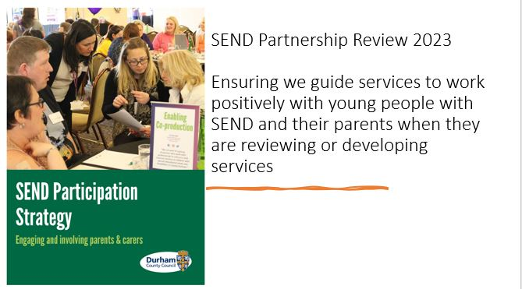

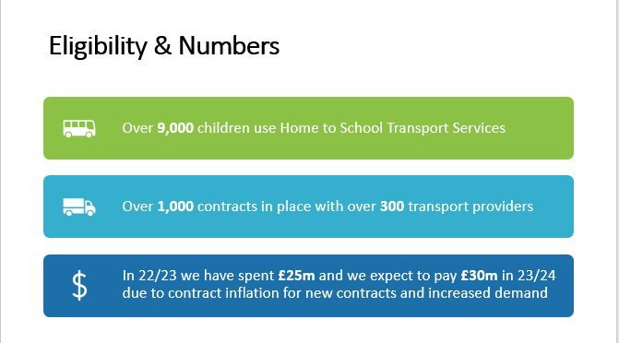

“Over 9,000 children use Home to School Transport Services, over 1,000 contracts in place with over 300 transport providers, costs have risen from £20m to £25m and we anticipate spending £30m next year.
We are confident that we can provide a better offer for Children and Young People and improve costs This is why we are conduction the review.”
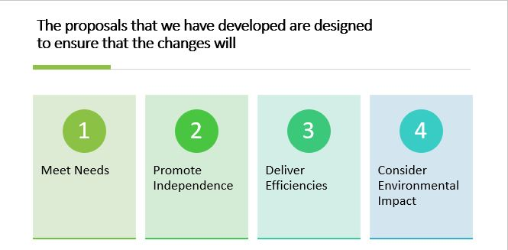
“Continue to Meet Needs, Promote Independence, Deliver Efficiencies & Consider Environmental Impact”

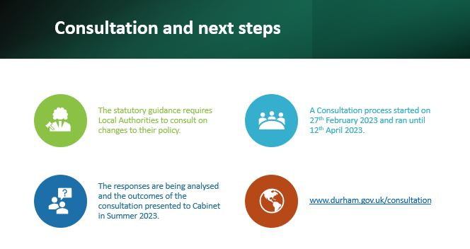
“I want to thank all of those who responded to the consultation either in person through the workshops or in response to the survey.
We have had a really positive response and we are confident that we will be able to propose some positive changes to the cabinet later this summer.
I have left a link to the consultation pages which will be updated as progress is made.”
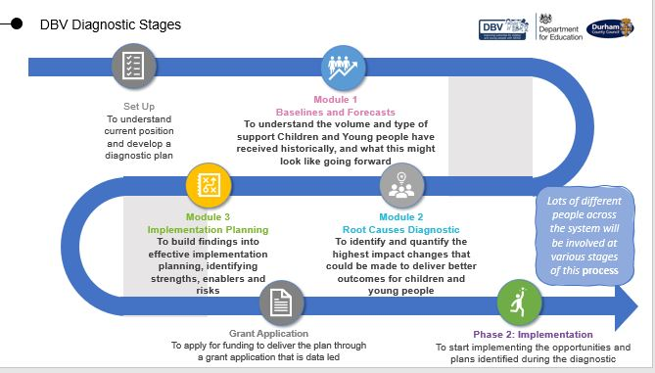

“Module 1 – We looked at the things that were happening in our communities that stood out to us as being unusual and where we might be able to make appositive impact.
We saw that most requests for a statutory assessment came just before a transition – This was in the early years moving into reception from nursery and from primary to secondary school. Prior to the assessment request young people had often been making their own progress in their community
We saw that we have a lot more young people in Special Schools than the rest of country.
We also saw that the steepest rise in demand was through young people being referred to us for their education because they had been permanently excluded or because they were too ill to attend. Those who were too ill to attend typically were struggling with anxiety.
Module 2 – We reviewed in partnership with schools and other professionals 50 cases of young people who fell into the categories.
We agreed that in the majority of instances (64% in SEND and 100% in pupils referred to us) needs could have been met in the child’s local school.
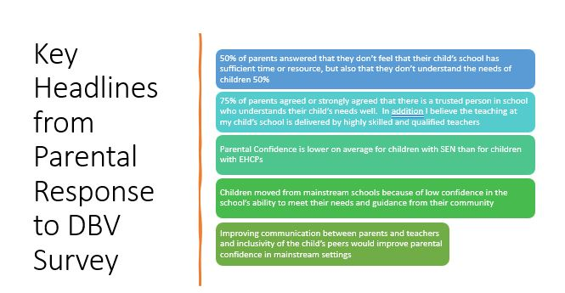
Module 3 – Stakeholder and Parent Carer Survey. “
“Parental Confidence is lower on average for children with SEN than for children with EHCPs – this promotes the need to get more help and advice to families with children receiving SEND Support”.

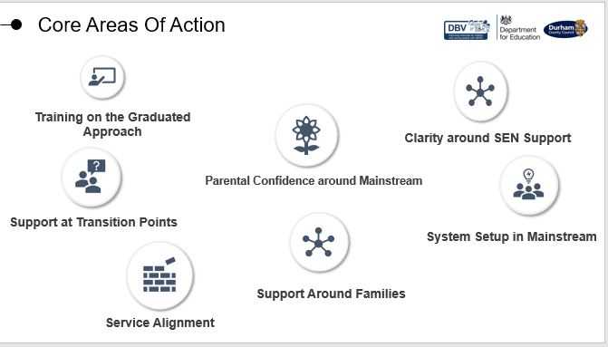
“Opportunities to Work in Coproduction”

“ Thanks for Your Time. Get in Touch - paulshadforth@durham.gov.uk "

Team Training Update.
Speaker - Victoria Robinson from MCT
Victoria updated everyone on the changes within Team training. She explained we are all sad to see Rollercoaster Family support cease which means they are no longer part of team training and can no longer provide the full list of “Creative Education” training. There is still some free training available at https://www.creativeeducation.co.uk/courses-for-parents-and-carers
Victoria explained Margaret Brewerton from NHS is facilitating extra training for professionals and forensic CAMHS are now doing some training too.
Victoria also mentioned that the training often has high numbers of people requesting places BUT many people simply don’t show up or send apologise.
If you sign up to workshops, training, conferences, or any other activity and cannot attend PLEASE let the organiser know asap so they can offer places to other people.
You can view all the team training available at https://www.mctdurham.co.uk/parent-carer-training-workshops/
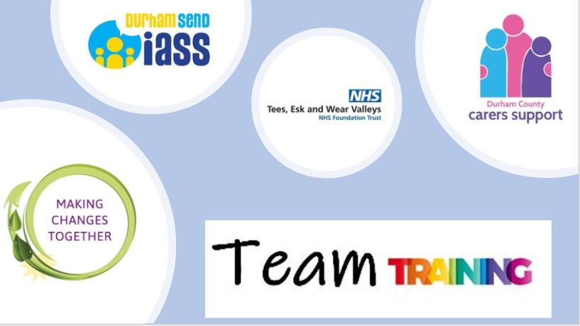
Team training slides below…
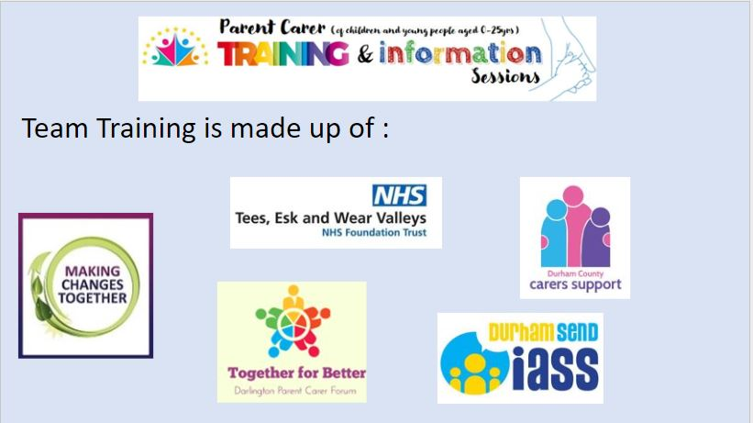
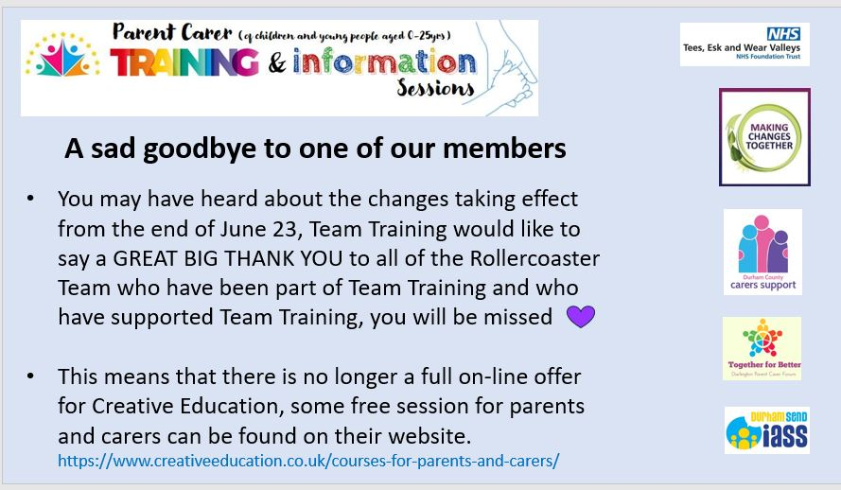

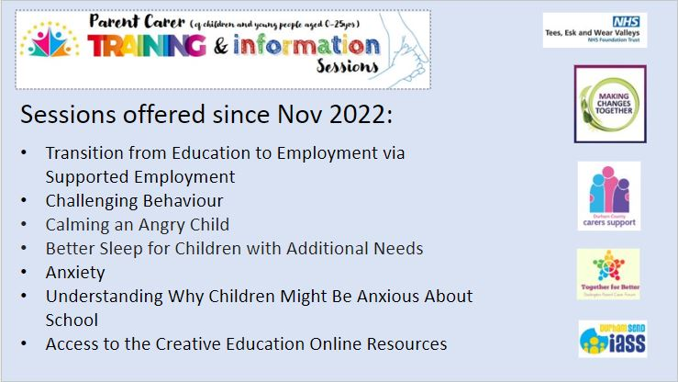
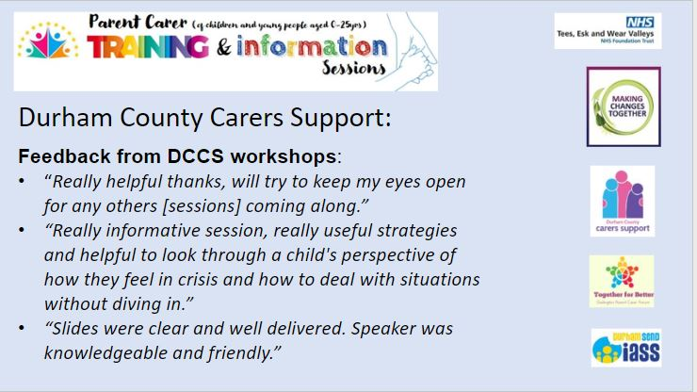

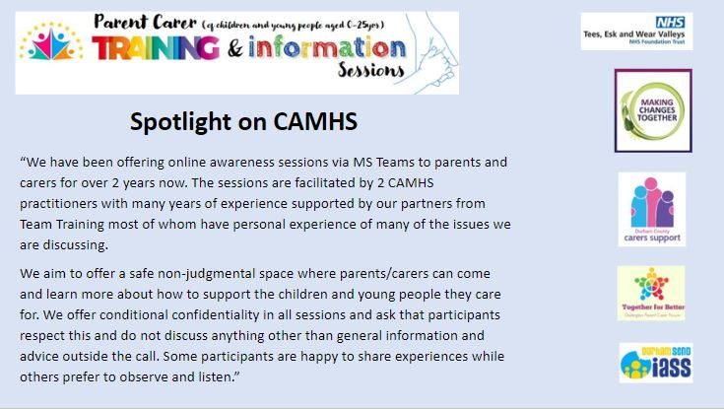

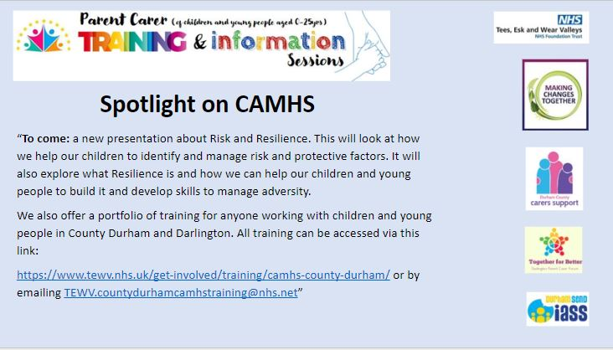

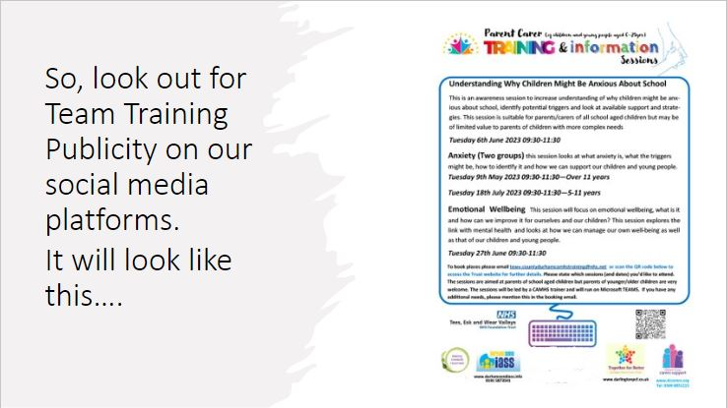
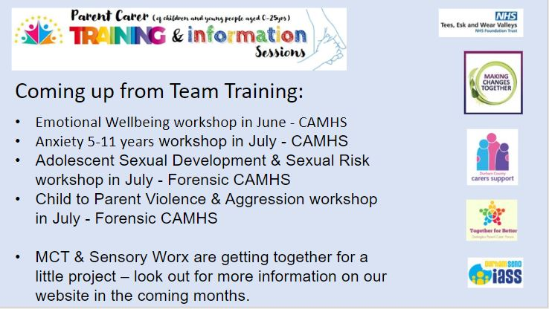

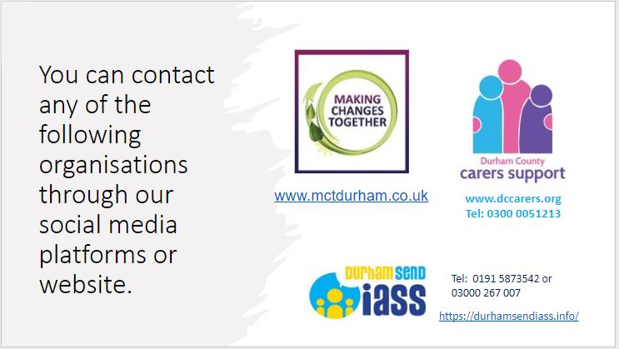
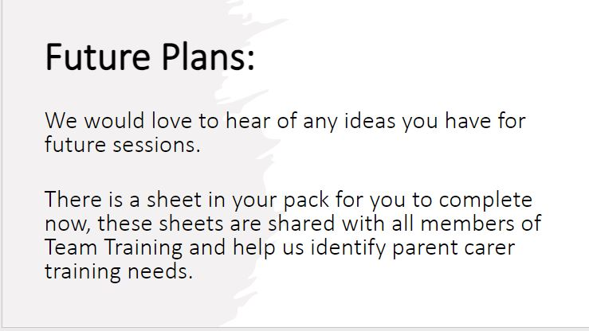
Victoria explained she would take all training suggestions back to the team training planning and feedback meeting on 12th July 2023.

MCT - Have you say!

MCT asked parents and carers to grab a post it note and write: -
- Something in education, health, social care or in general that IS going well.
And / or
- Something in education, health, social care or in general that is NOT going well.
This allowed parents and carers to share their praise and air their grievances. We got dozens of post it notes with both praise and issues written on them.
The feedback will be collated asap. We will try to raise issues with the relevant department, and we will feedback to everyone soon.

MCT also played a video over lunch showing what they have done since November 2022 conference., View the video on YouTube here- https://www.youtube.com/watch?v=-23EWO7Kj_M&t=6s

DSCO – Designated Social Care Officer – Judith Bowman.
Judith explained her previous role was One Point Operation Manager and her new job as DSCO is a brand-new role introduced in County Durham in February 2023. The main job as DSCO is raising the profile of SEND (Special educational needs and disabilities) within social care.
Judith explained she had introduced some MANDATORY training for social care staff.
Judith also wanted to share the training from EPEC (Empowering Parents Empowering Communities). A 12-week course for parents and ran by parents who have been fully trained. For more info on EPEC email EPEC@durham.gov.uk or read about it on the LA website here https://www.durham.gov.uk/article/28221/Help-a-child-get-their-best-start-in-life-by-training-with-Empowering-Parents-Empowering-Communities-EPEC

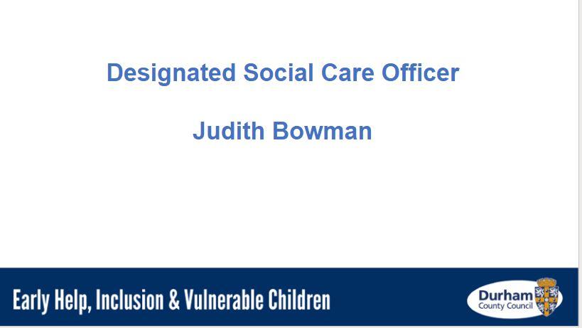
Judith’s slides below -
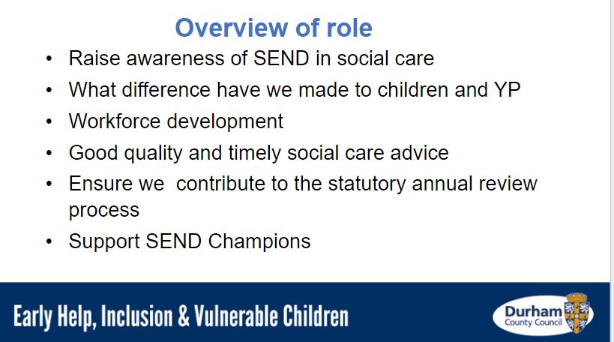
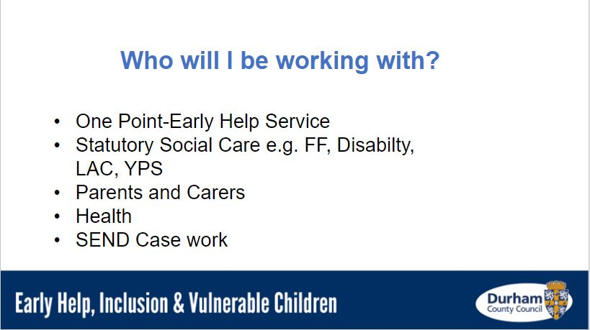
– 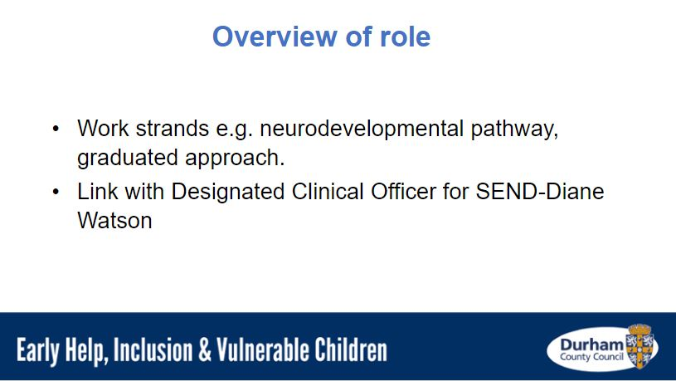

Judith’s contact details are -
Email - Judith.Bowman@durham.gov.uk
Telephone – 03000 261550

Neurodevelopmental Pathway Update - 1
Speaker-
Alison Ayres​ - Commissioning Manager for Children’s Services​.

At our evening conference we had Alison Ayres as our speaker for this topic. For the daytime conference we had Rachael Allen and Paula Gardner who gave an update on “County Durham and Darlington Needs Led Neurodevelopmental Pathway” plus Alison Ayres again who gave an update on “Building a needs-led system for families with neurodivergent children and young people​”.

Alison Ayres slot slides summary 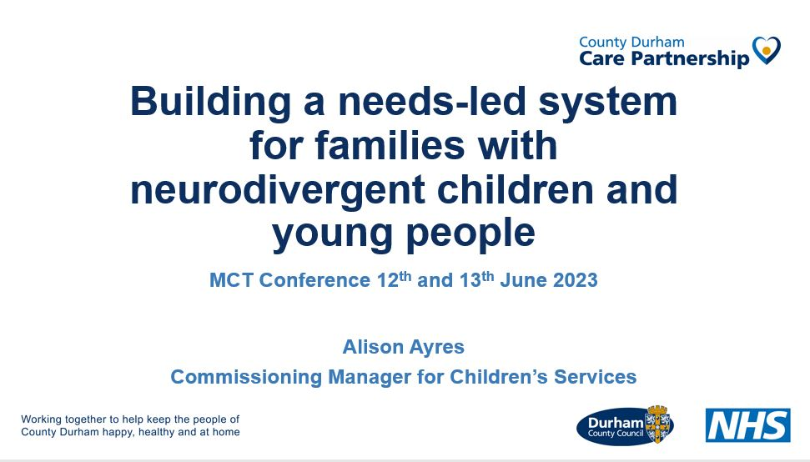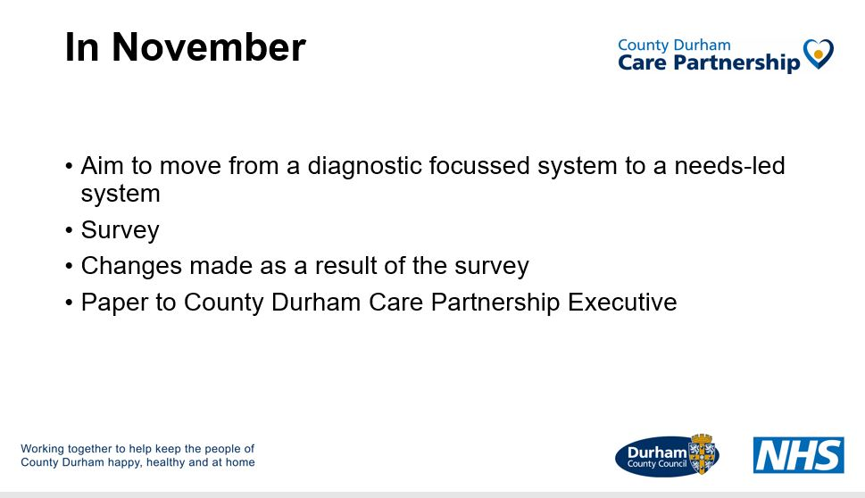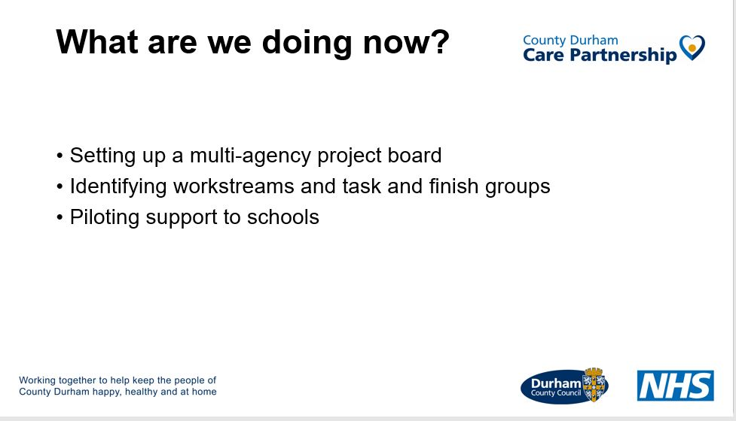
Alison explained she wants to improve support and advice for neurodiverse parents and carers.
Alison explained the money for a pilot of supporting teachers in schools is currently taking place North Durham Academy, Stanley, and Consett Academy plus their primary feeder schools.
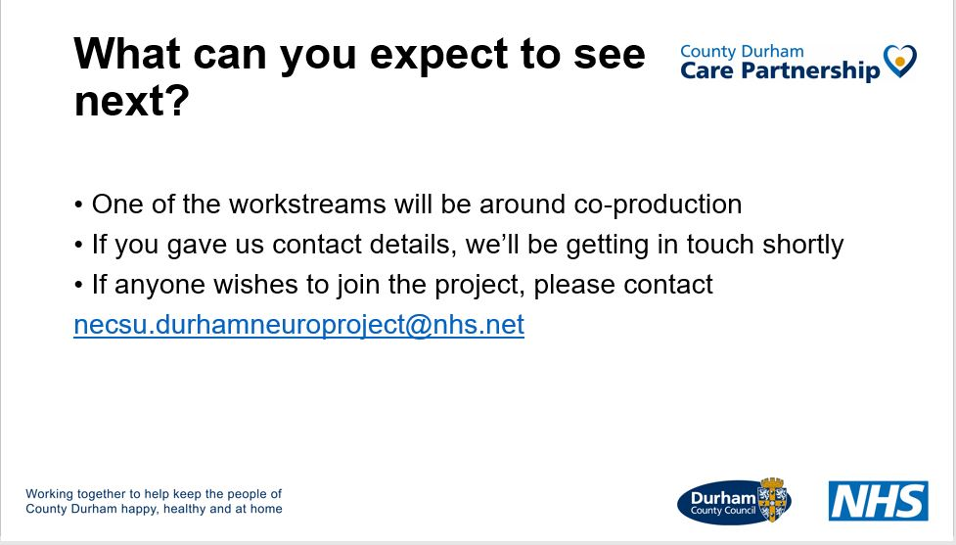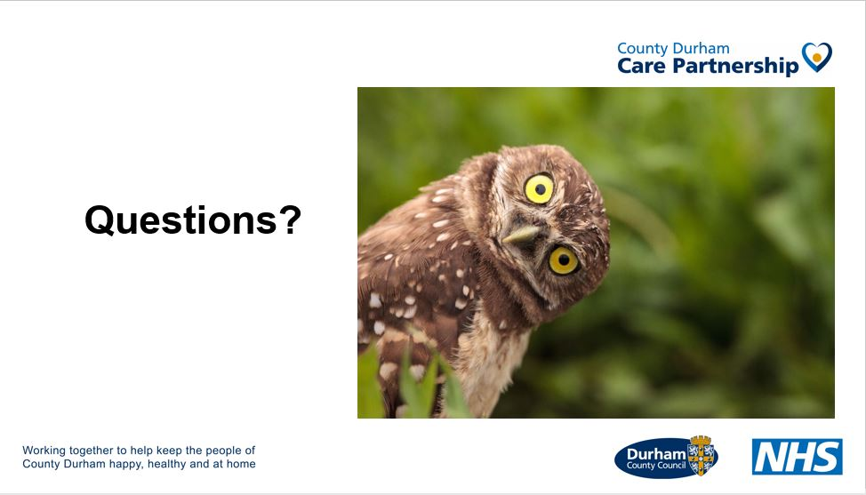

Someone in the audience asked Alison-
- “How long is the waiting list to be assessed via the Neurological pathway?” (To be assessed for Autism and / or ADHD)
Alison’s answer was “Around 40 months!” (Over 3 years wait)
Neurodevelopmental Pathway Update - 2

Speakers -
Rachael Allen - Team Manager at Tees, Esk & Wear Valleys NHS.
Paula Gardner, Clinical Nurse Specialist at Tees, Esk & Wear Valleys NHS

At our evening conference we had Alison Ayres as our only speaker for this topic. For the daytime conference we had Rachael Allen and Paula Gardiner who gave an update on “County Durham and Darlington Needs Led Neurodevelopmental Pathway” plus Alison Ayres again who gave an update on “Building a needs-led system for families with neurodivergent children and young people​”.
Rachael & Paula’s slot slides summary

County Durham Care partnership hosted webpage for the Neuro pathway here –https://nenc-countydurham.icb.nhs.uk/our-work/needs-led-neurodevelopmental-pathway/

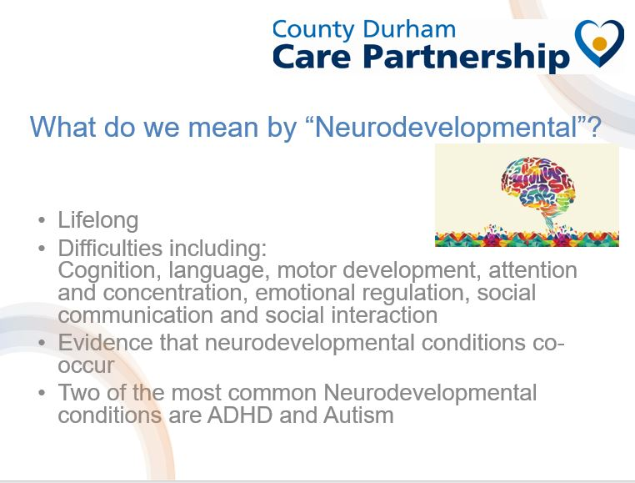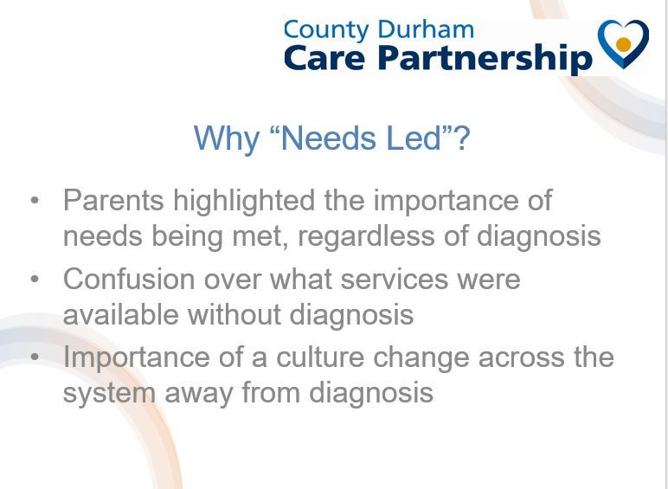
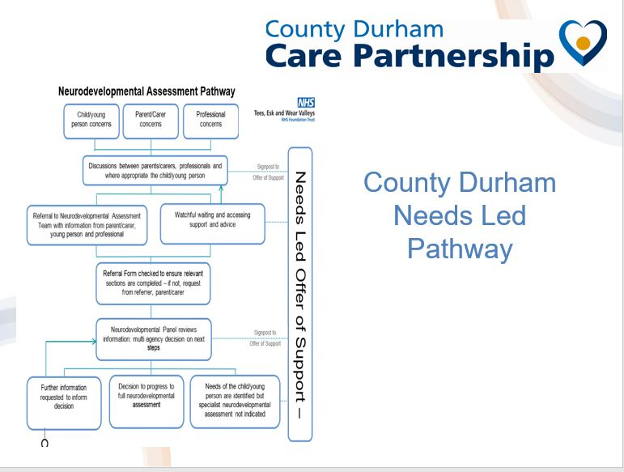Link to clearer image of the slide above can be found here –
https://nenc-countydurham.icb.nhs.uk/wp-content/uploads/sites/13/2021/10/0001-scaled.jpg
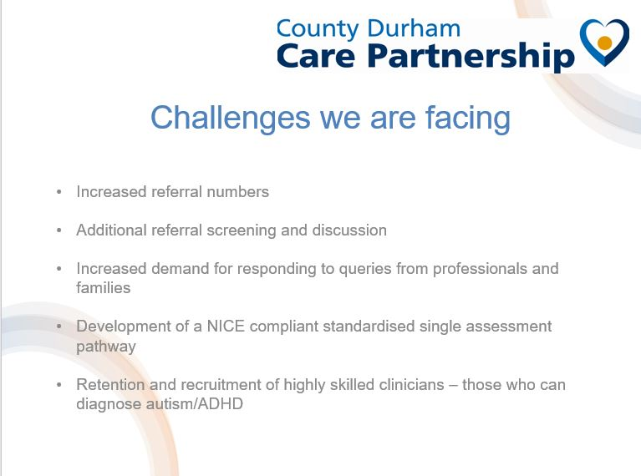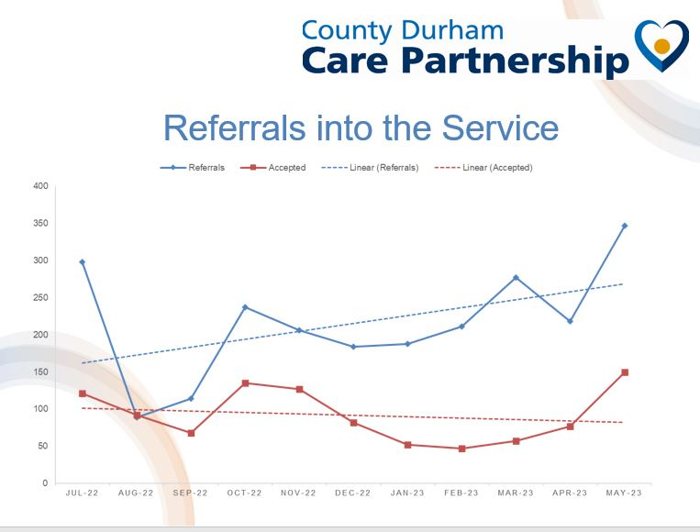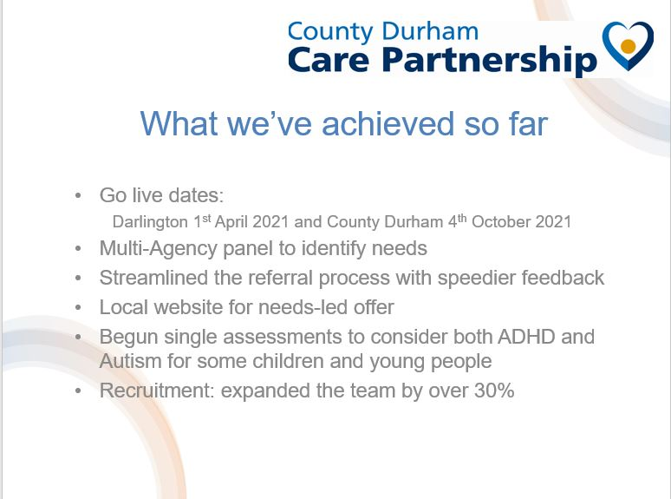

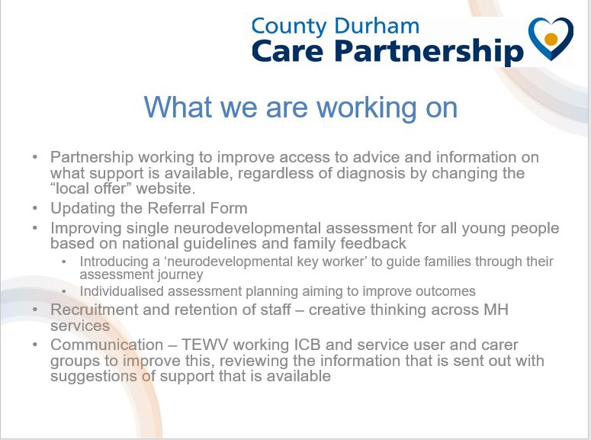
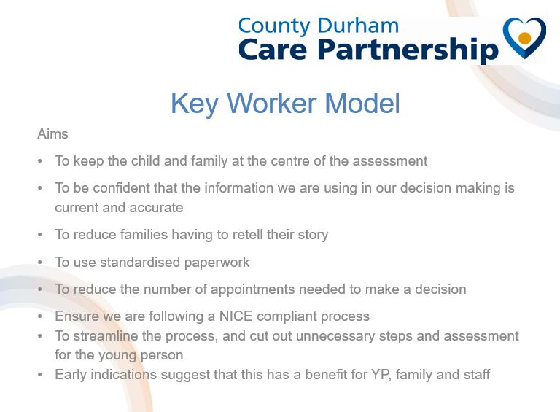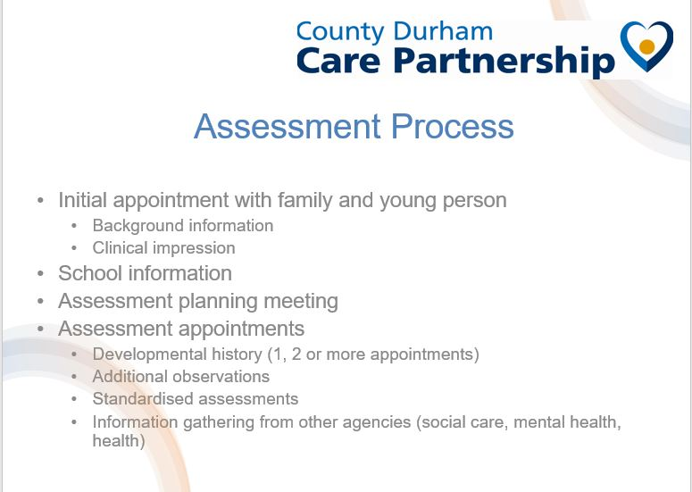
Some questions asked by delegates to Rachael and Paula-
- “How many young people are on the waiting list to be assessed via the Neurological pathway?”
Rachael answered, “Around 5000 over Durham and Darlington”.
- “How does it work to get a diagnosis private and not via the NHS pathway?
Rachael answered “We are looking at options to bring down numbers on waiting list. This may include private companies.” Rachael wasn’t sure on the full details on the “right to choose” options which means going to your GP and being referred to a private company or another area for an autism and / or ADHD assessment to get it quicker. Many GPs will not refer to a private company.
- “How long is the waiting list from a diagnosis of ADHD to getting an appointment within CAMHS for medication?”
Rachael wasn’t sure and said she would check. MCT will update this info asap via our website new section.

SENDEIC – (Special Educational Need empowering Inclusive Communities) – Short breaks.
Speakers –
Lyndsey Dunn - Commissioning, Planning and Policy Officer (Project lead)
Ruth Pope - Enabling Inclusive Communities Co-ordinator.
Danielle Pope - Inclusive Communities Co-ordinator.

- Link to short breaks information here – www.durham.gov.uk/shortbreaks
- Link to new YouTube video here – www.youtube.com/watch?v=oH52uc15Ow8
- Link to register your young person with Childrens and Young people’s network and to get a max card – Ring 03000 265 792 , email cypn@durham.gov.uk or do it online https://www.durham.gov.uk/cypn .

Lyndsey explained that new name for short break solutions was “SEND empowering Inclusive Communities” as they wanted parents to be empowered and not feel they need solutions,
She explained Danielle Pope was first single point of contact. She would check what activities were out there already for young people in order for parents / carers to get a break from their caring role. She would also signpost to other organizations and activities. If Danielle was unable to find anything available for a young person in their area, she would then pass the case on Ruth Pope who would try to enable access and remove barriers for a young person to enable them to attend a local, community activity.
Lyndsey explained they hoped to help build family confidence so children were able to access mainstream activities they otherwise couldn’t.

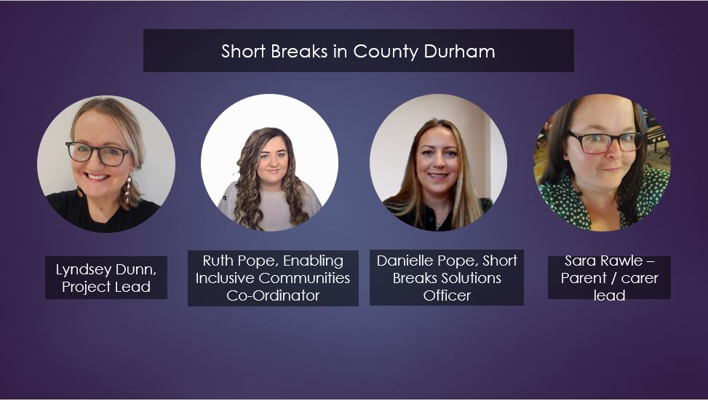
SENDEIC Slides –

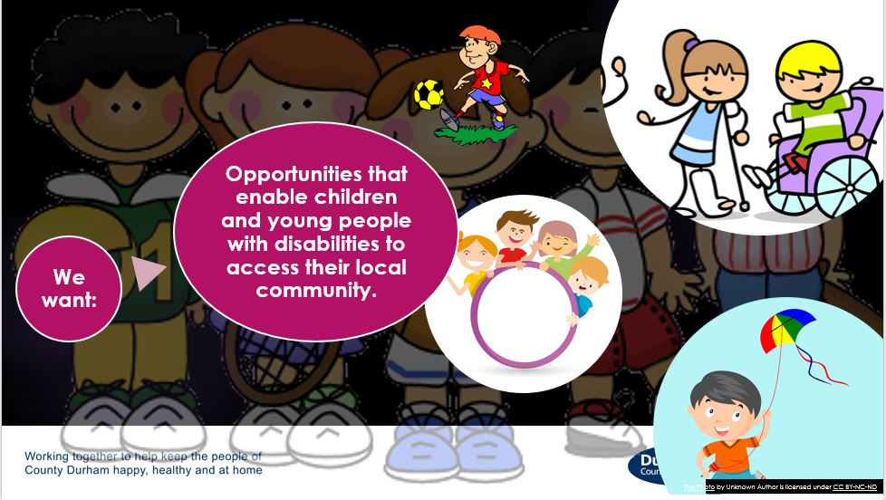
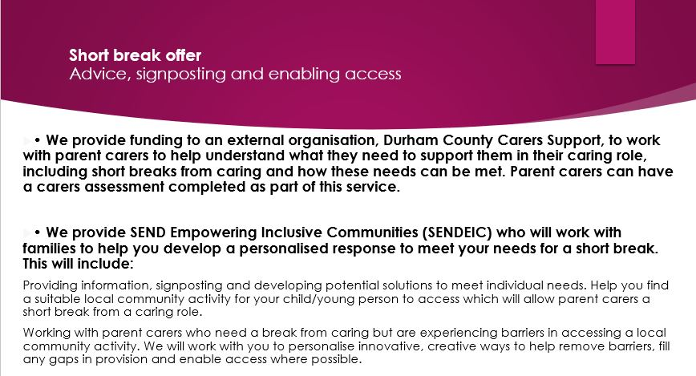

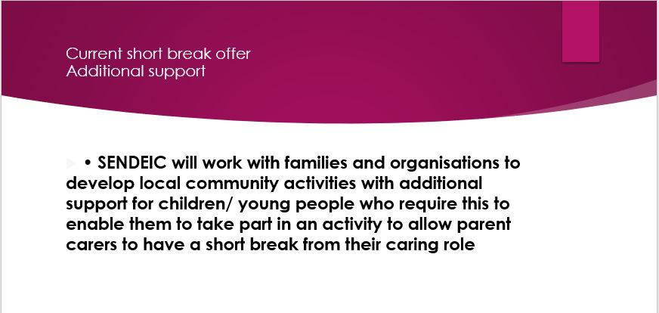

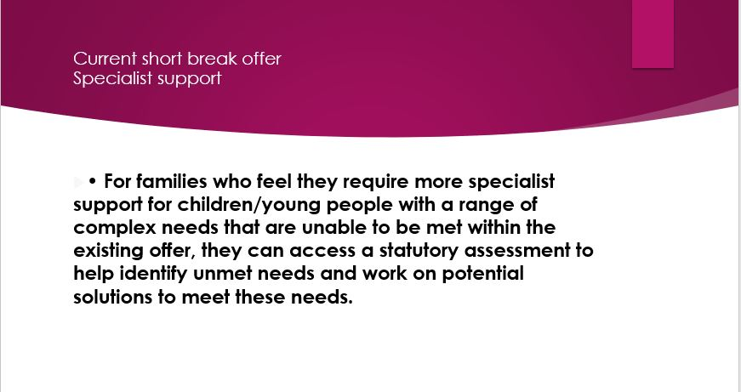

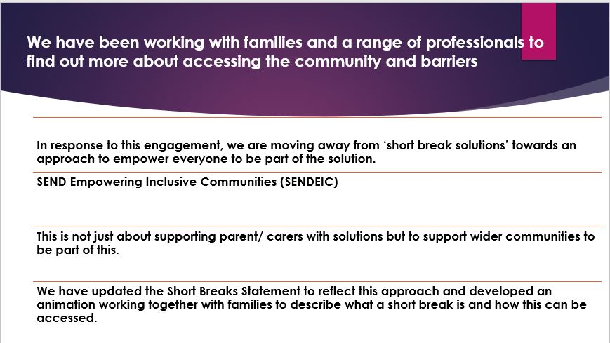
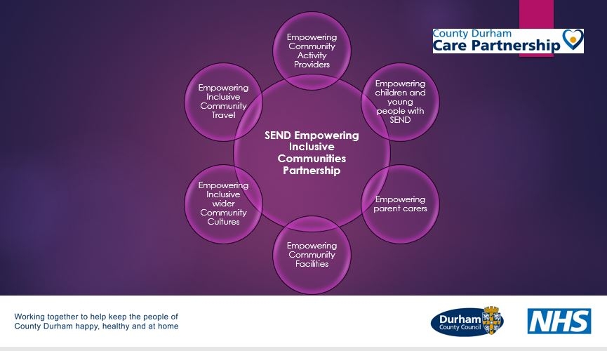

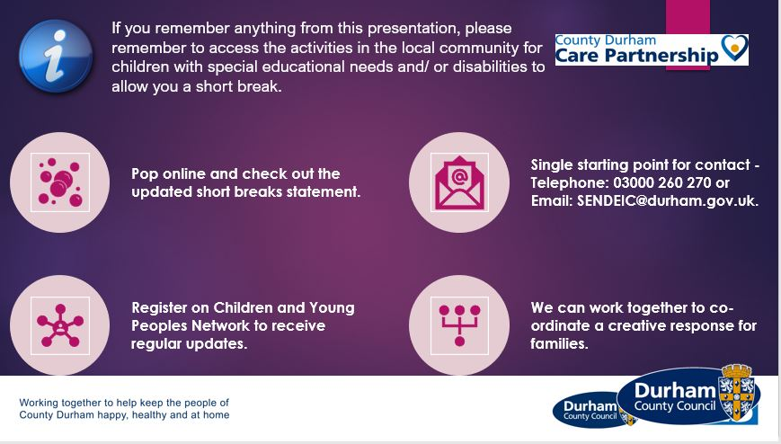
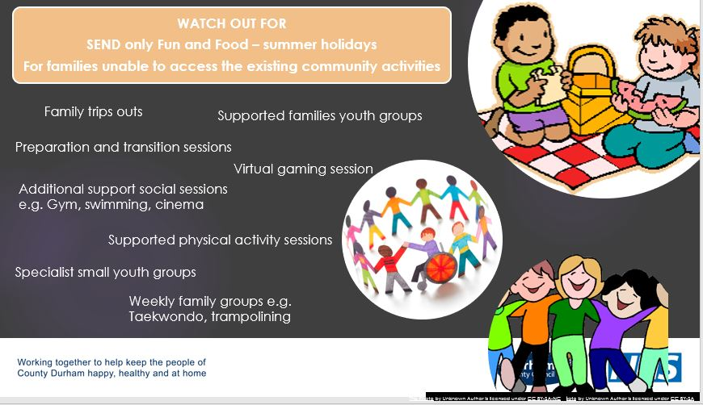

SENDIASS UPDATE
Speaker – Lisa Kirton - County Durham SENDIASS Co-ordinator & North East Regional IASS Representative.

At the end of her slot Lisa asked delegates to fill in a form which asked 3 questions -
- What does SENDIASS do well?
- What could SENDIASS do better?
- How could SENDIASS develop the offer to families?

SENDIASS Slides-

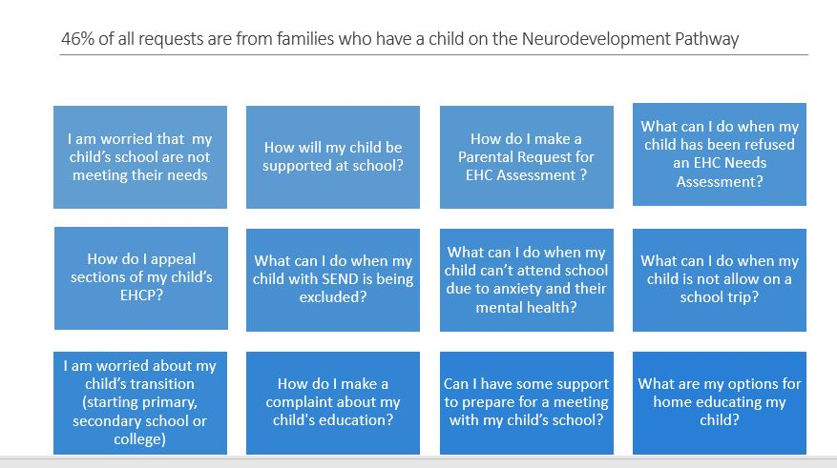
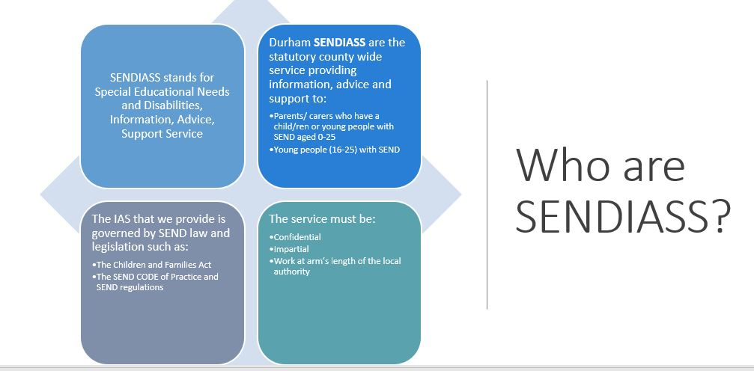

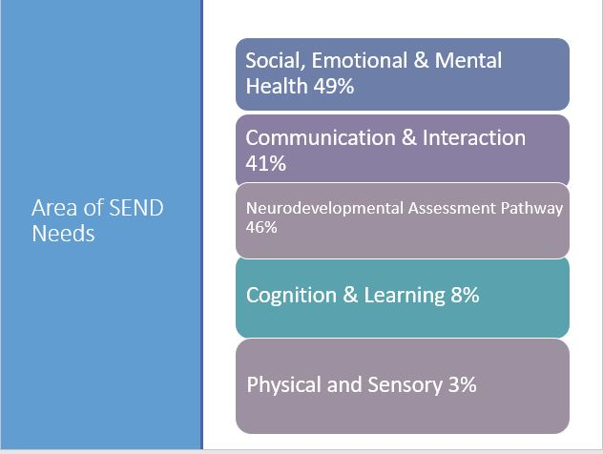

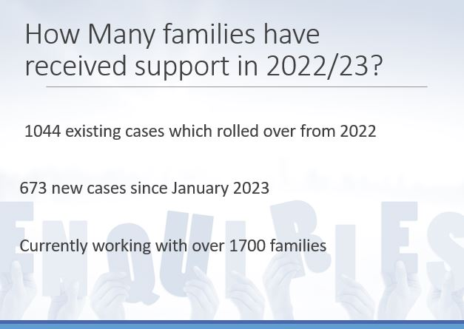

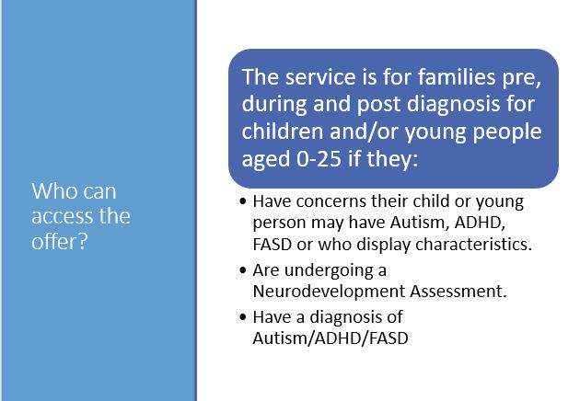
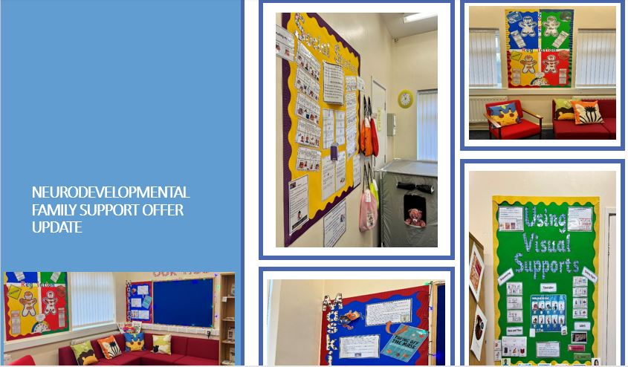
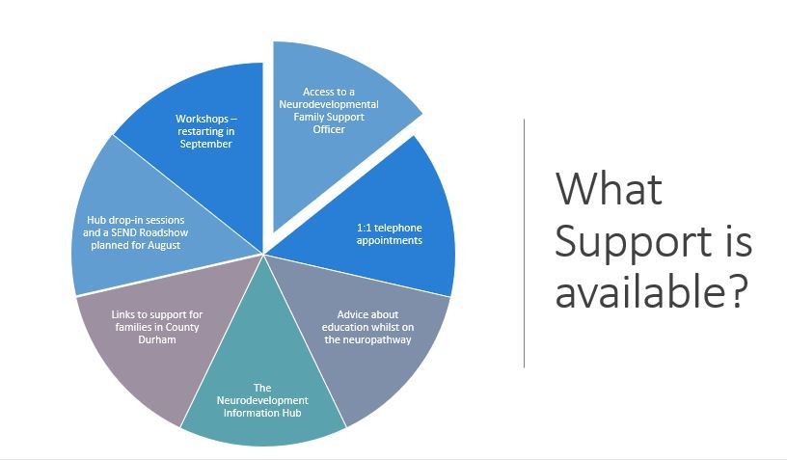

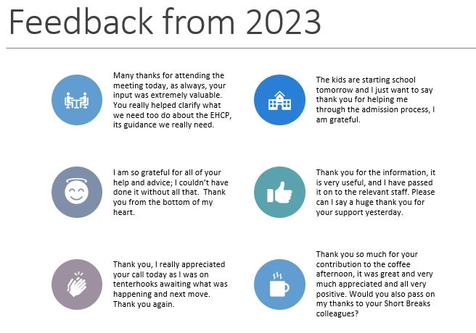
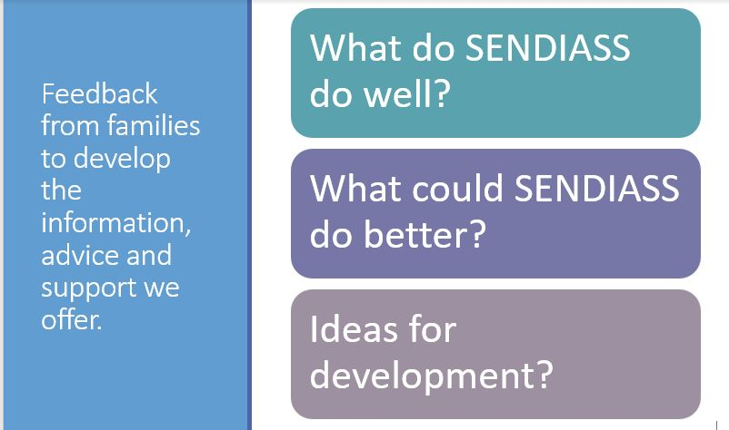

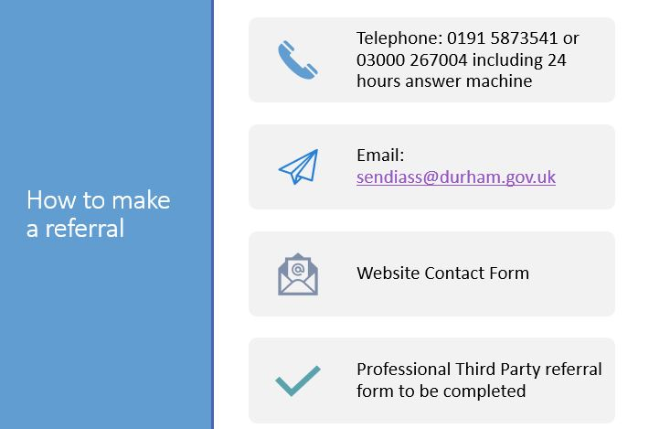
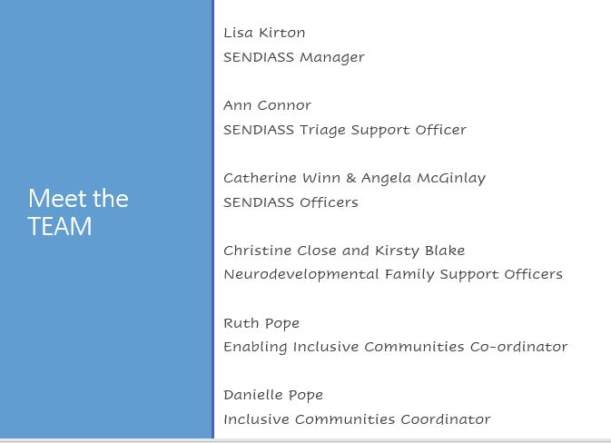
Investing in Childrens - eXtreme Group
Speakers –
Freya – Young person & long-time member of the eXtreme group.
Louise Frost - Project Worker/Peer Support Worker at IIC.

Louise explained about Investing in Children – They are an organisation that helps empower young people, to help empower their rights in day-to-day life and to help improve lives.
Louise explained that Freya had been attending the eXtreme group for 7 years and had better experience than her 😊.
Freya told us that the eXtreme group meet once a month to discuss issues and anyone ages up to 25 can attend. Young people get paid to attend and Freya explained young people do get their voices heard.
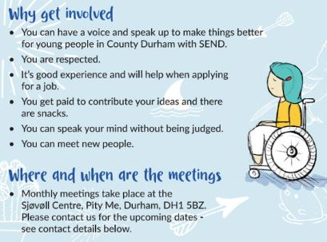
Louise explained the new “your autism” website and Freya read her story from the screen. Find the website and young people’s stories here - https://yourautism.co.uk/ . Freya got the BIGGEST applause of the night after this slot.
eXtreme group slides here –

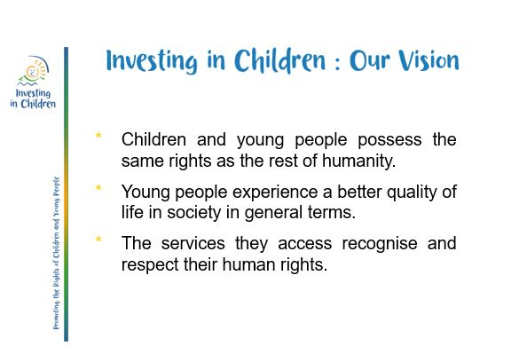

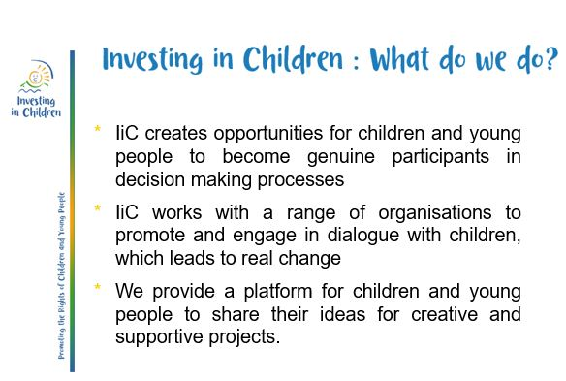

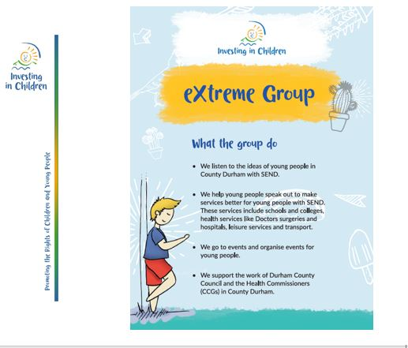

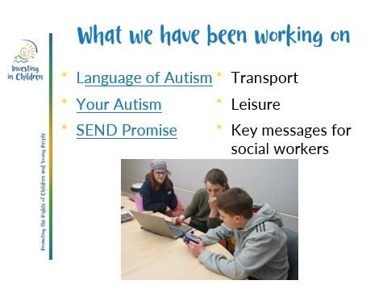

Sensory Worx
Speaker – Claire Stirland – Occupational therapist, advanced sensory integration practitioner and director of Sensory Worx.

Claire spoke of her younger life and sensory overload experience in the local shopping centre.
Claire brought out a full chocolate cake and some dried mealworms. She portioned the cake up and distributed it to delegates along with pots of mealworms to represent cream. This demonstrated to the room how their reaction to seeing mealworms on a cake and to be expected to eat it has similarities to that of a child or young person with food based sensory difficulties. Claire then tipped the mealworms onto the cake, brushed the mealworms off and proceeded to offer the “worm dust topped” cake representing how the “repulsive item” was not completely removed. This analogy showed how children and young people with sensory / food issues feel if certain foods are mixed, touching or remnants of food removed from their plate by a parent / carer and same plate given back. If child or young person feels this way, they are not having their sensory needs met.

Sensory Worx slides –

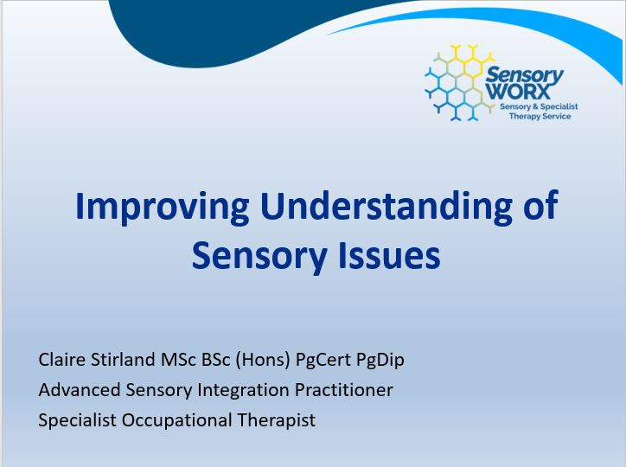

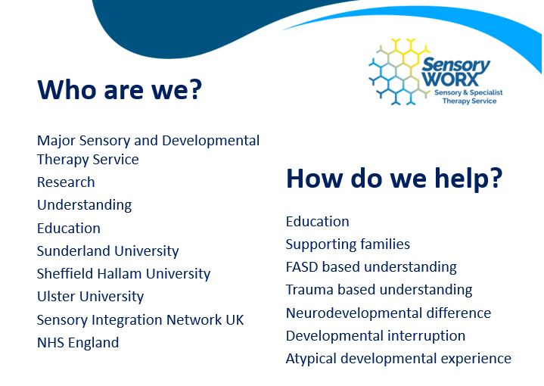

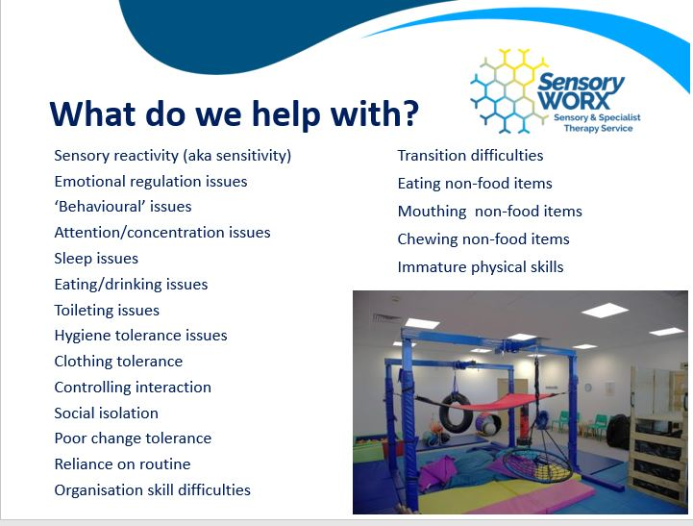

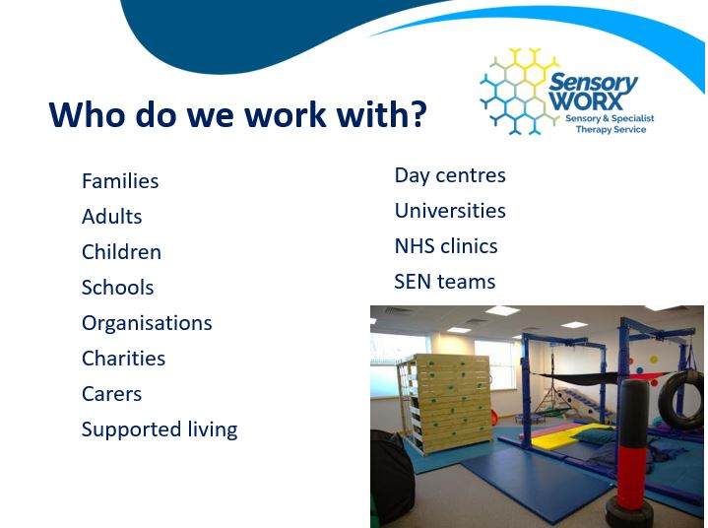

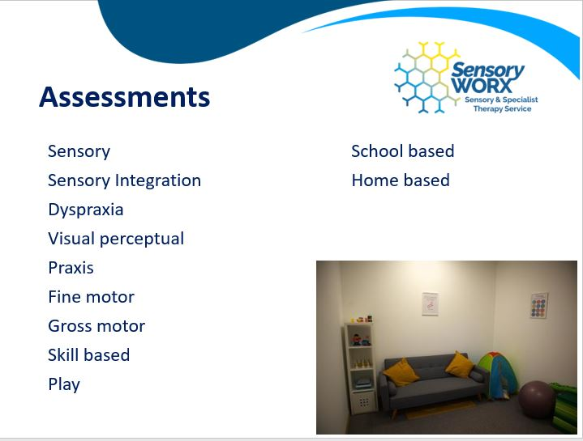

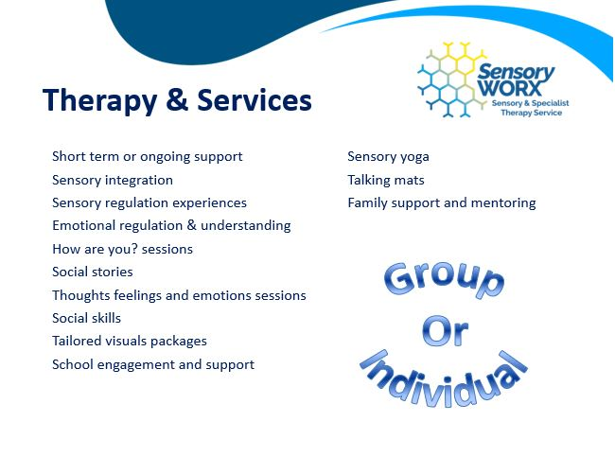

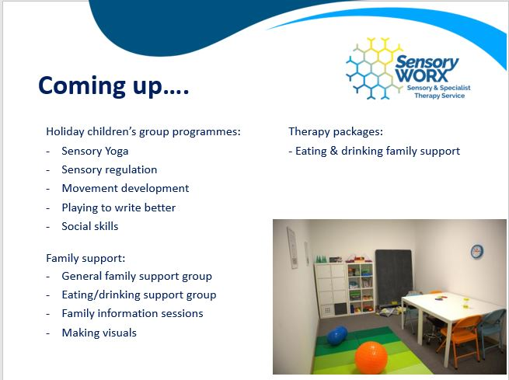

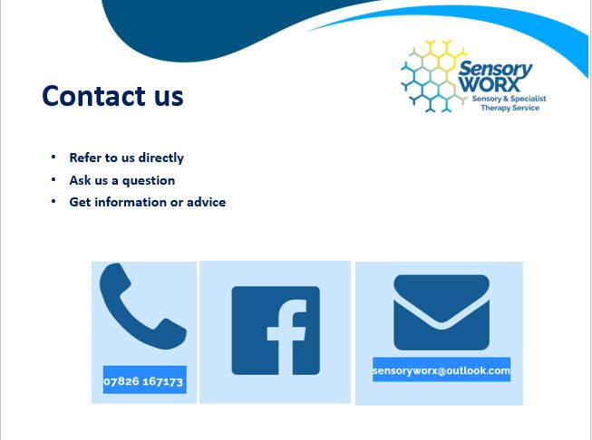

PCP – Learning disability & autism project
Speaker – Paula Meale - Senior research officer.
PCP is the Pioneering Carer partnership who are a third-sector charitable organisation aiming to improve health, wellbeing and learning for all.
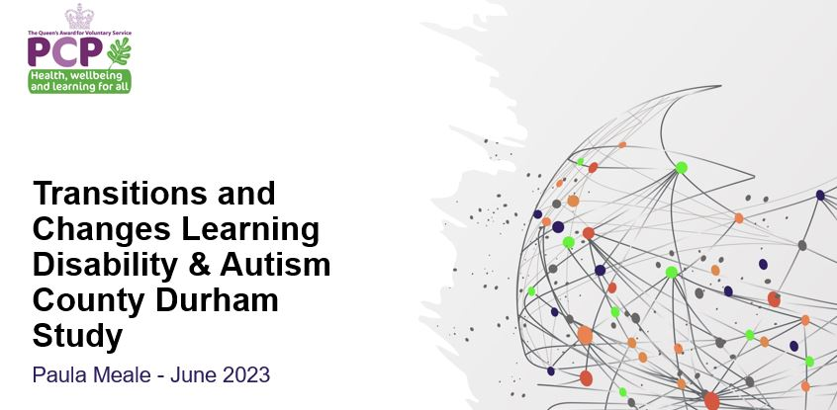

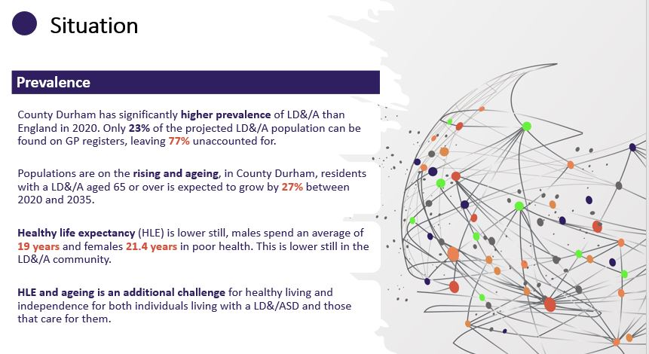

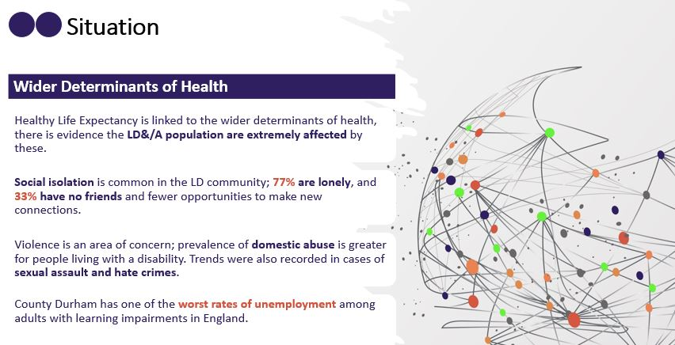

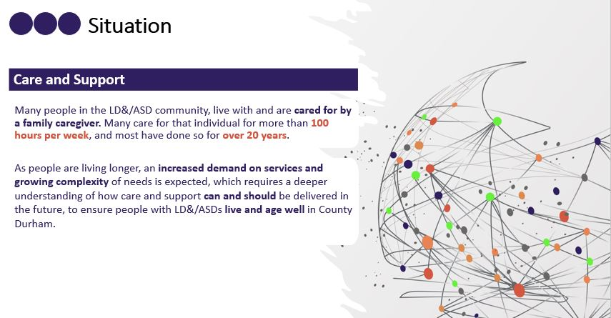
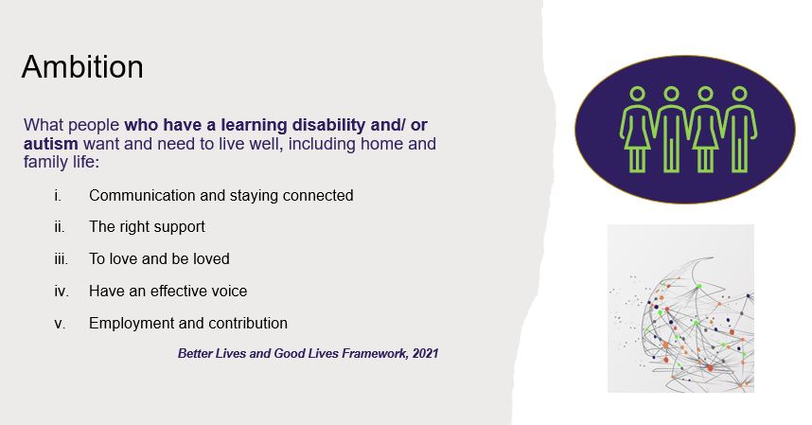

Paula asked, “Does your child or young person HAVE everything they need to live a happy ordinary life within County Durham”. A few delegates raised their hand.

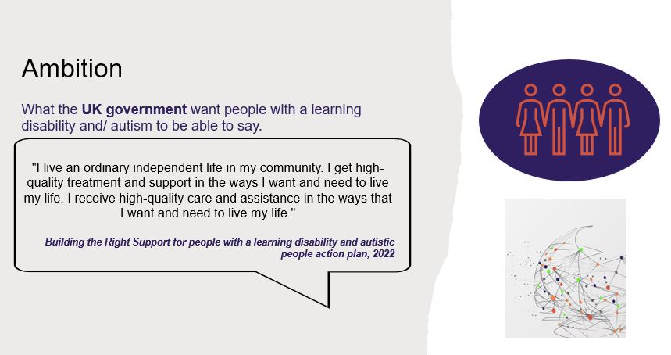

Paula then asked, “SHOULD your child or young person HAVE everything they need to live a happy ordinary life within County Durham”. All delegates raised their hand.
Paula then asked, “COULD your child or young person HAVE everything they need to live a happy ordinary life within County Durham”. A large number raised their hand.

A delegate raised her hand and pointed out that she is an autistic adult and “Doesn’t want to live an ordinary life and is living the life she wants & the government shouldn’t be putting wording into her mouth.”

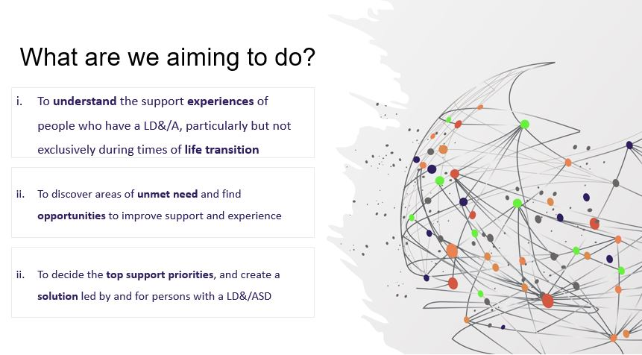

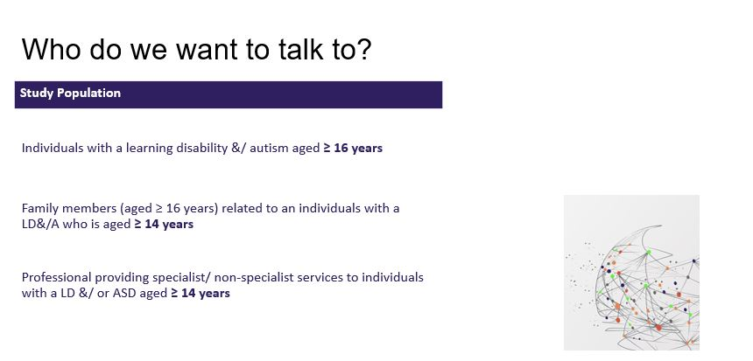

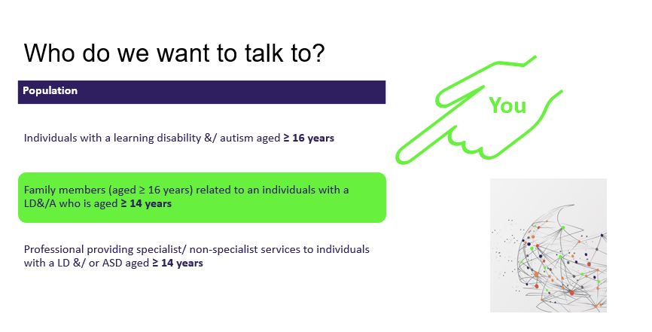

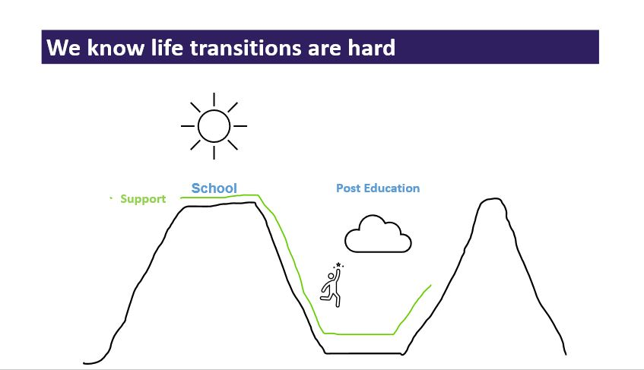

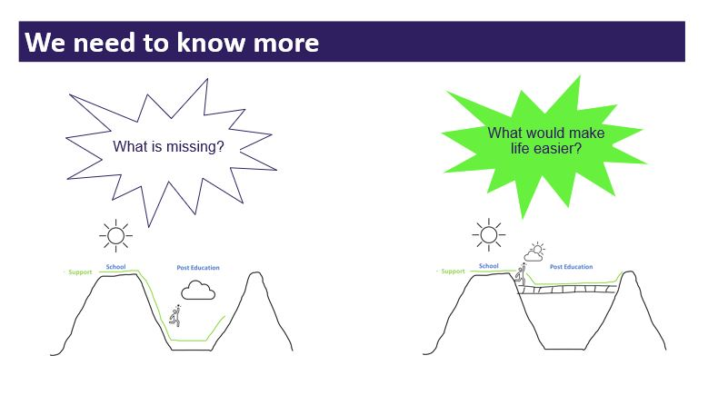

At the end Paula asked delegates about funding in County Durham and a member of the audience said he thought it was a “Postcode lottery”.
We encourage eligible people who have a learning disability and/ autism to take the survey below - (Survey closes July 2023)
https://www.surveymonkey.co.uk/r/J9PPSY2
Raffle and Close.

Raffles took place at both events with a range of lovely prizes won by delegates. Marsha thanked everyone for coming and asked delegates to complete the evaluation forms.
At the day conference other MCT members thanked Marsha for her years of hard work within the forum and gave her a leaving gift. Her knowledge and experience will be sorely missed.

Conference Evaluations
Daytime conference.
Head - Something I’ve learnt from today.
- Short break offer
- That there isn’t enough funding or staff for our kid’s needs.
- SENDEIC – support for young adults with severe anxiety issue.
- Learning more information.
- What SENDIASS offer.
- Sensory needs and their impact on individuals affected.
- My child has unmet needs, and the local authority needs to implement support for this.
- About the services that Sensory Worx offer.
- CYPN offer a discount card.
- The dental team.
- What services are available in my area.
- To know there is a support setting for my older son for his future.
- Smile through sport.
- Change in assessment process.
- Information regarding early help & access to carers breaks.
- To be my daughter’s voice and advocate!
- Changes to transport to be considered.
- 12-week course to deliver training.
- Throughout the holidays they are looking into groups for children to stay by themselves – SENDEIC.
- What support is available from SENDIASS
- Many professionals offered evidenced based advice and support for various aspects of day-to-day life with a child with SEN.
- There are lots of organisations out there who are willing to support. Working together is important.

Heart - Something I’ve felt / experience today.
- Not everyone understands the processes & why should they?
- Proud of MCT but upset there is nothing available to help my socially anxious 20-year-old.
- To note how passionate but frustrated parent carers are feeling. I feel very sad for those parents who are trying to help their young person to lead, as much as possible, a successful & happy life.
- Food was lovely.
- That I am not alone. There are other parents in the same boat.
- Sense of empowerment.
- Disappointed in strategic services presentation and plans using stats to justify their poor planning and future services.
- I’m not alone – others are experiencing similar difficulties.
- Angry and upset – that the “business” of the broken system is affecting my daughter care.
- Having conversations with other parents and carers who understand.
- The passions of people attending to make changes better for CYP & families. Enjoyed Clare (sensory Worx) presentation.
- Enjoyed & learnt a lot.
- Some nice positives & heard some nice things.
- Opportunity to talk to people from different organisations about SEND.
- Happy sensory issues are becoming more recognised, Sad the assessment process still has such a long waiting list.
- Emotional but comfortable. Seen! Heard! The amazing network that’s available! Alive- not alone!
- How everything is so delayed in implementing changes.
- Support from Claire at Sensory Worx. As I currently feel overwhelmed with lack of professional support for my son.
- eXtreme Group. Have your say – good / not do good.
- It has been a friendly & welcoming day by all professionals and attendees supporting one another in similar situations.
- Conflicted?! While the support is there- I don’t feel it’s always advocated via schools etc and what kind of things they can provide with their services.
- Although there is still a way to go County Durham still seems to be doing well too other part of the Country.

Carrier Bag – Something I’ll take away from today.
- Some parents still have limited information/ understanding of services.
- A full tummy Thank you.
- DSCO – Social care – linking in social work.
- Freebiees.
- SENDIASS info
- Lots of support services to look into.
- Freebies- thanks!
- Information to share with other parents & carers at my son’s school.
- Links with services & professionals.
- Info.
- Lots of useful leaflets and more knowledge on things that are available.
- Good info & goodies.
- Upcoming sessions with sensory Worx
- Where to access help with respite / carers breaks.
- All the support that’s available to make the links.
- Sensory Worx information.
- Aware not that my son with additional needs as well as my “neuro typical” daughter are both able to attend activities together. Looking into Taekwondo.
- Food (lunch).
- In it together.
- My voice so I can ask / express what I feel “We” need / expect and / or if those are going to be met / accessed.
- Knowledge of different support networks available and the ease of access to these.
Dustbin – Something that was not good about today.
- Waiting lists.
- Hearing there’s a recruitment drive but no staff available.
- Nothing
- Can’t think of any.
- Paul Shadforths presentation.
- I had to leave early and missed the sensory Worx presentation.
- Nothing- thank you
- Wordy PowerPoints.
- Air con
- Virtual presentation not a good as the live presentation (even if it is unavoidable)
- Some of the professionals lack the knowledge around waiting times for treatment after diagnosis.
- How broken this system is. Waiting lists people in roles who don’t understand.
- Focus on autism instead of learning disabilities. Not all LD are diagnosed ASD.
- Lack of being able to give timescales of the Neurodevelopmental team waiting list.
- Nothing
- No negatives
- Nothing – it was a great day.

Evening conference:
- People at MCT are lovely!

Head - Something I’ve learnt from today.
- Waiting list times for assessment.
- Team training
- SENDEIC offer.
- About the teams that are helping us try and help our daughter.
- Love the changes so far.
- Learnt SENDIASS are working with 1700 families and 46% of carers seeking SENDIASS assistance have neurodivergent children - Didn’t realise it was this high.
- Professionals talk a good game but what you say & what they deliver is very different things. Clearly don’t live in the real world.
- There is a website with all the information held centrally.
- Things about home to school transport.
- There is a lot of information out there.

Heart - Something I’ve felt / experience today.
- Opportunity to talk to other parents.
- Anger, frustration & maybe hope.
- Hope.
- Shared experiences.
- Things about SENDIASS.
- SENDIASS developing information and advice for 16-25 years and this is currently missing. I hope it provides opportunity for individuals to make decisions independently.
- We’ve asked for help for months & received very little support. Feel very angry and disappointment.
- There is a lot of others looking for the same information & support.
- Welcomed.
- Included.
- Included.
- There are a lot of departments all doing similar things. A little overwhelmed but thankful.

Carrier Bag – Something I’ll take away from today…
- Info on services
- The information & services
- Freebies
- Empowering Inclusive communities – short breaks- very positive steps for families.
- Self-congratulation for yourselves. (Professionals not MCT)
- To look for more help & access to services that are available.
- Things discussed at the last conference WAS NOT forgotten about and has been updated.
- Information leaflets.
- Information.
- It was good to put a name / face to phone calls and some more contact details for new opportunities.

Dustbin – Something that was not good about today.
- All good stuff. Nothing for the bin
- Nothing of note.
- Too hot
- What’s been said does not reflect the support you say is available. How come you don’t show negative feedback?
- It was all great.
- Nothing.
- It was all good – just a lot of info for a first timer.

MCT DURHAM CIO – Registered charity number 1202217.
www.mctdurham.co.uk

